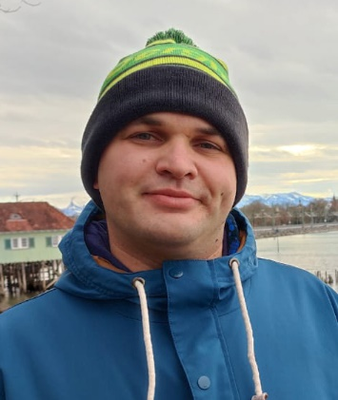

|  |  |  |  |
| --- | --- | --- | --- |
|  | | Serhii Tarasiuk  Trainee QA/QC  Phone: +380979964964  Email: serhiy.slm@gmail.com  Skype: Tarasiuk Serhii | |
| I am a very motivated and enthusiastic person with a high willingness to learn. I am excited about IT and agile methods of software development and looking forward to further growth in this area.  My ability to comprehend things fast, and to think outside of the box help me to adapt to any situation.  In addition to this, my resilience abilities and emotional stability enable me to find solutions even in stressful situations. | | | |
| Skills | RDBMS   * MySQL * PostgreSQL   Methodologies   * Agile, Scrum   Operating Systems   * Microsoft Windows * Ubuntu | | Development Tools   * VS code   Graphics editors   * Photoshop * Corel Draw |
|  | **Easyrest** | | |
| Project Description: | Online service for restaurant management. | | |
| Customer: | Softserve IT Academy | | |
| Involvement Duration: | 2 months | | |
| Project Role: | QC manual tester, SCRUM master | | |
| Responsibilities: | * User Stories making; * Test Cases making; * Bug report making; | | |
| Project Team Size: | 12 team members | | |
| Tools & Technologies: | Python Pyramid, JavaScript React, Material UI, Jira, Zephyr | | |
|  |  | | |
| Languages | Ukrainian native | | |
| English b2 | | |
| German a2 | | |
| Certifications | Practical Testing in Softserve IT Academy | | |
| Hobbies | Mountain hiking, cross country bicycle riding, | | |